Defect report

1. Exploratory Testing:
   * Defect 1 - The “SHOP” tab redirects to the wrong page.
   * Defect 2 - The “ABOUT US” tab redirects to the wrong page.
   * Defect 3 - Unwanted content on the contact page.
   * Defect 4 - Incorrect language, unwanted content in the “Contact” URL and uncentered footer.
   * Defect 5 - Disappearing icons in the “Quantity” tab.
2. Specification-Based Testing:
   * Defect 6 - Administrator cannot create a new CR.
   * Defect 7 - Administrator cannot add comments to visible CRs.
   * Defect 8 - After completing the edit, the CR does not switch to "read-only" mode.
   * Defect 9 - Unable to assign a user to a provider.
   * Defect 10 - Incorrect provider account creation form.
3. UI/UX Testing:
   * Defect 11 - Inactive tabs have an incorrect color.
   * Defect 12 - The "GET STARTED" button has incorrect font size and background.
   * Defect 13 - Incorrect icon size and missing symbol in header.
   * Defect 14 - Incorrect sizes for the h1:after line and the text below in section id="about-us".
   * Defect 15 - Incorrect sizes for h6 headers with descriptions in section id="about-us".

**#1**

**Title:**

The “SHOP” tab redirects to the wrong page.

**Description:**

After clicking the “SHOP” tab in navigation menu, the user is redirected to the blog page instead of the shop page.

**Steps to reproduce:**

1. Open the website <https://skleptest.pl/>.
2. Click the “SHOP” tab in the navigation menu.

**Expected Result:**

The user is redirected to the shop page.

**Actual result:**

The user is redirected to the blog page.

**Environment:**

* Application version: unknown
* Browser: Google Chrome 133.0.6943.127
* OS: Windows 10

**Attachment:** 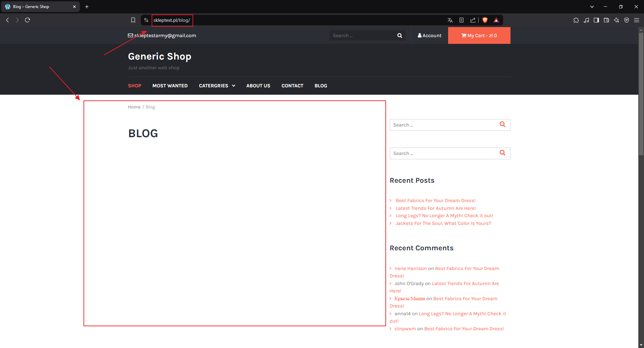

**#2**

**Title:**

The “ABOUT US” tab redirects to the wrong page.

**Description:**

After clicking the “ABOUT US” tab in navigation menu, the user is redirected to the “Contact” page instead of the “About us” page. Additionally, both tabs (“ABOUT US” and “CONTACT”) are highlighted.

**Steps to reproduce:**

1. Open the website <https://skleptest.pl/>.
2. Click the “ABOUT US” tab in the navigation menu.

**Expected Result:**

The user is redirected to the “About us” page. Only “ABOUT US” tab is highlighted.

**Actual result:**

The user is redirected to the “Contact” page. Both the “ABOUT US” and “CONTACT” tabs are highlighted.

**Environment:**

* Application version: unknown
* Browser: Google Chrome 133.0.6943.127
* OS: Windows 10

**Attachment:** 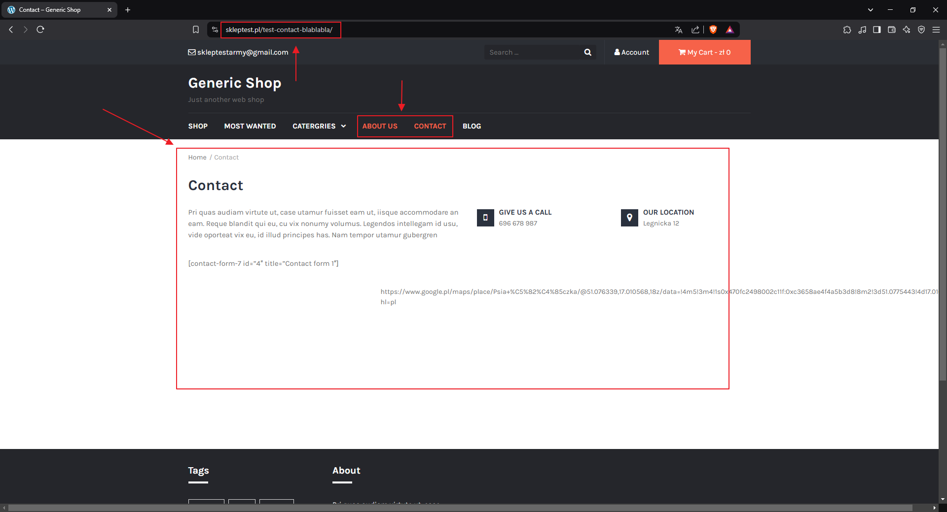

**#3**

**Title:**

Unwanted content on the contact page.

**Description:**

There are unwanted visible elements such as [contact-form-7 id=”4” title=”Contact form 1”], incorrectly placed inside the <p> HTML tag, and a Google Maps link ([link](https://www.google.pl/maps/place/Psia+%C5%82%C4%85czka/@51.076339,17.010568,18z/data=!4m5!3m4!1s0x470fc2498002c11f:0xc3658ae4f4a5b3d8!8m2!3d51.0775443!4d17.010752?hl=pl)) placed directly in a <div> (div id=”tyche-map”). The Google Maps link also breaks the page design, causing the text not to wrap correctly.

**Steps to reproduce:**

1. Open the website <https://skleptest.pl/>.
2. Click the “CONTACT” tab in the navigation menu.

**Expected Result:**

Elements like [contact-form-7 id=”4” title=”Contact form 1”] should not be visible. The Google Maps link should be properly implemented and not break the page layout.

**Actual result:**

Elements like [contact-form-7 id=”4” title=”Contact form 1”] are visible. The Google Maps link is not properly implemented and breaks the page layout.

**Environment:**

* Application version: unknown
* Browser: Google Chrome 133.0.6943.127
* OS: Windows 10

**Attachment:** 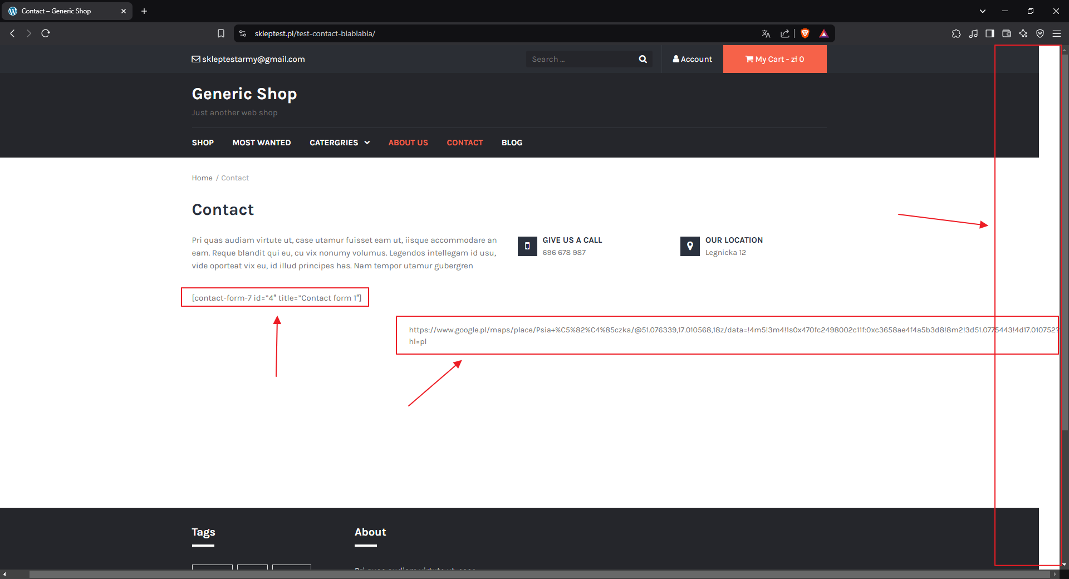

**#4**

**Title:**

Incorrect language, unwanted content in the “Contact” URL and uncentered footer.

**Description:**

On the “Contact” page, the text displayed in div (div id=”site-content”) and in footer is in Latin. The URL for the “Contact” page contains unwanted content “blablabla” (https://skleptest.pl/test-contact-blablabla/), and the footer is not centered.

**Steps to reproduce:**

1. Open the website <https://skleptest.pl/>.
2. Click the “CONTACT” tab in the navigation menu.

**Expected Result:**

Texts are displayed in English, The URL for the “Contact” page should be “https://skleptest.pl/test-contact/”, content in footer is centered.

**Actual result:**

Texts are displayed in Latin, The URL for the “Contact” page is “https://skleptest.pl/test-contact-blablabla/”, content in footer is not centered.

**Environment:**

* Application version: unknown
* Browser: Google Chrome 133.0.6943.127
* OS: Windows 10

**Attachment:** 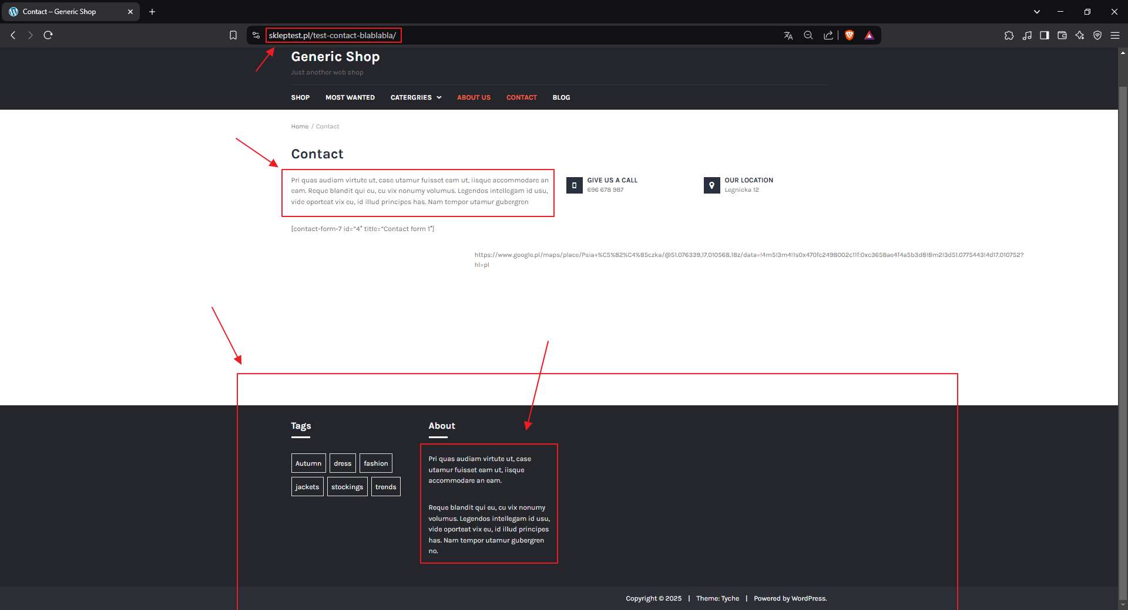

**#5**

**Title:**

Disappearing icons in the “Quantity” tab.

**Description:**

After increasing or decreasing number of products in cart and clicking the “UPDATE CART” button, the “-“ and “+” incons in the “Quantity” tab disappear.

**Preconditions:**

* The user has at least one product added to the cart.

**Steps to reproduce:**

1. Open the website <https://skleptest.pl/>.
2. Click the “My Cart” tab.
3. Click the “+” icon in the “Quantity” tab.
4. Click the “UPDATE CART” button.

**Expected Result:**

Quantity value is updated, and the “-” and “+” icons remain visible.

**Actual result:**

Quantity value is updated, and the “-” and “+” icons disappear.

**Environment:**

* Application version: unknown
* Browser: Google Chrome 133.0.6943.127
* OS: Windows 10

**Attachment:** 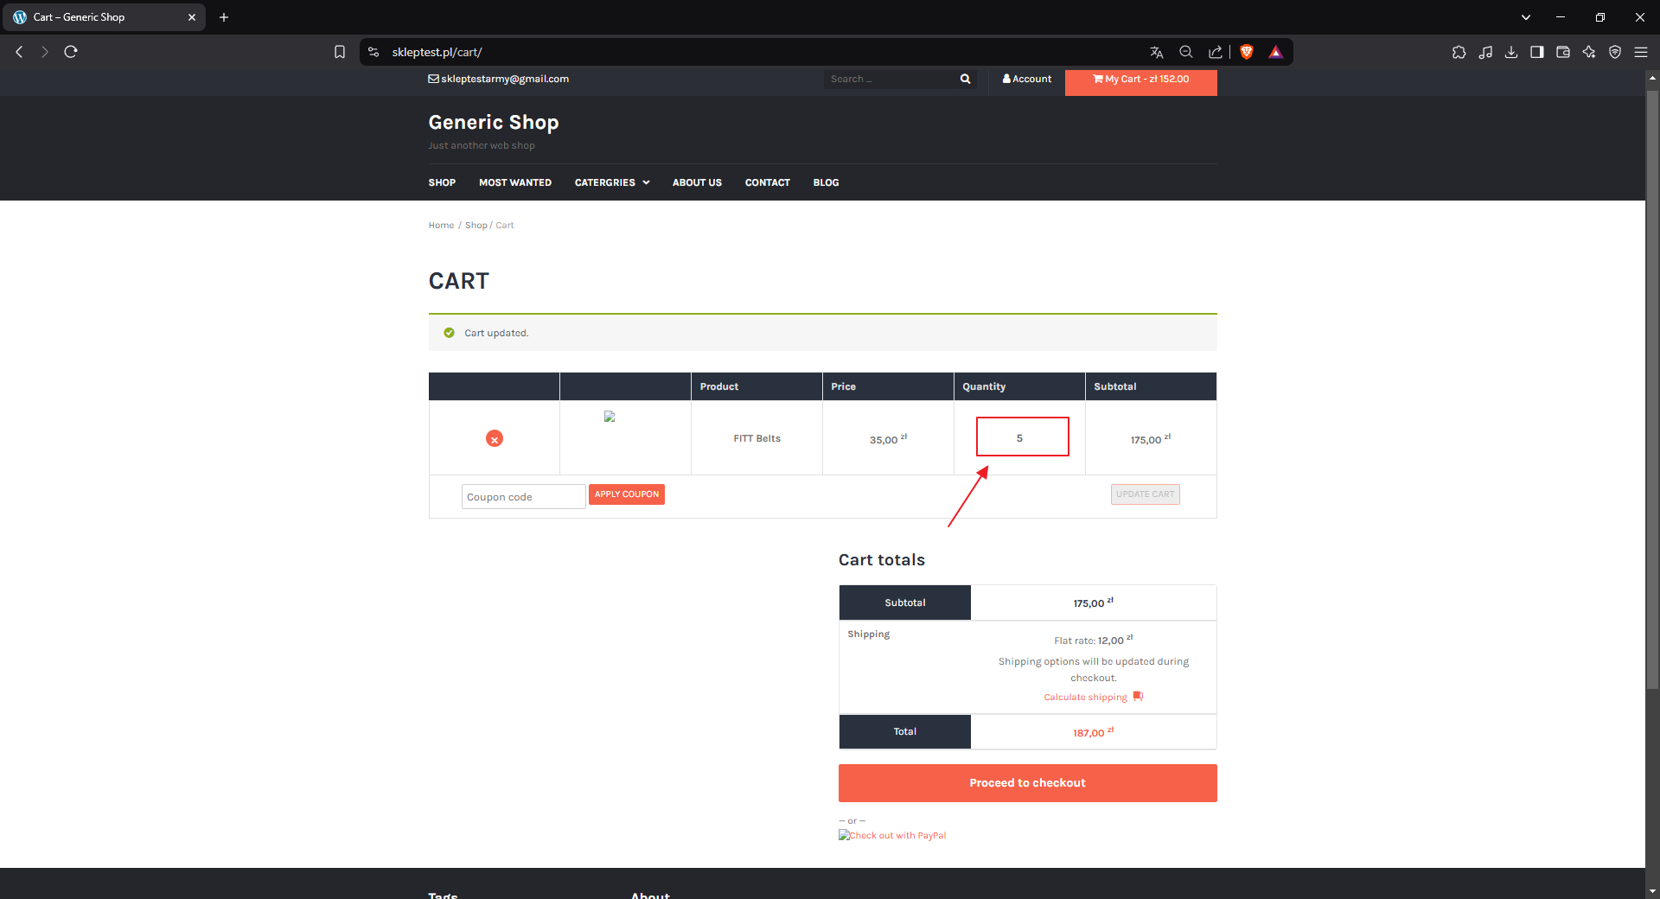

**#6**

**Title:**

Administrator cannot create a new CR.

**Description:**

In the "CRs" tab, the administrator does not have access to the button for creating a new CR.

**Steps to reproduce:**

1. Open the application.
2. Log in as an administrator.
3. Navigate to the "CRs" tab.

**Expected Result:**

The administrator should be able to create a new CR.

**Actual result:**

The administrator cannot create a new CR.

**Environment:**

* Application version: MrBuggy7 1.0.0.1
* OS: Windows 10

**Attachment:** 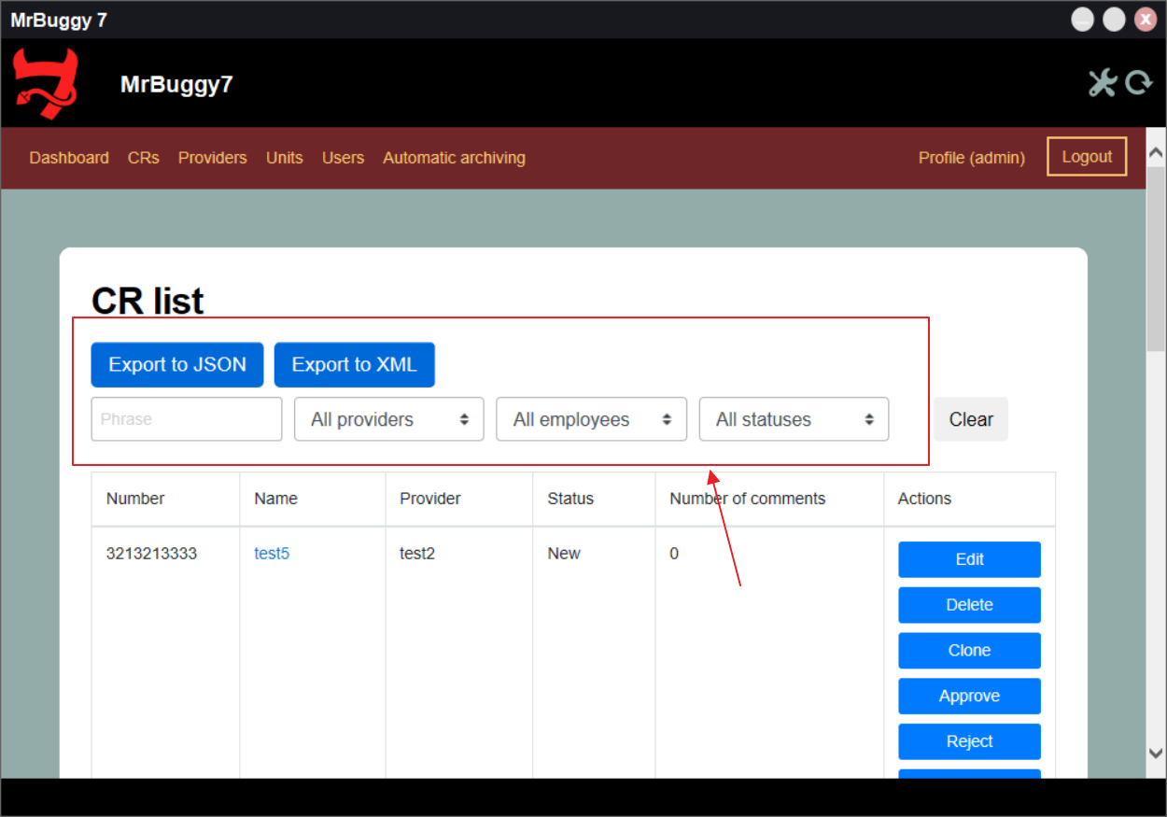

**#7**

**Title:**

Administrator cannot add comments to visible CRs.

**Description:**

In the single CR view, the "Comments" tab is displayed. However, the administrator cannot add a comment if the CR does not have any existing comments. (If the CR is cloned, comments can be added in the clone).

**Steps to reproduce:**

1. Open the application.
2. Log in as an employee.
3. Click on the "CRs" tab.
4. Click the “New CR” button.
5. Log out.
6. Log in as an administrator.
7. Click on the “CRs” tab.
8. Click the link in the “Name” column of the given CR.

**Expected Result:**

The administrator should be able to add a comment.

**Actual result:**

The administrator cannot add a comment.

**Environment:**

* Application version: MrBuggy7 1.0.0.1
* OS: Windows 10

**Attachment:** 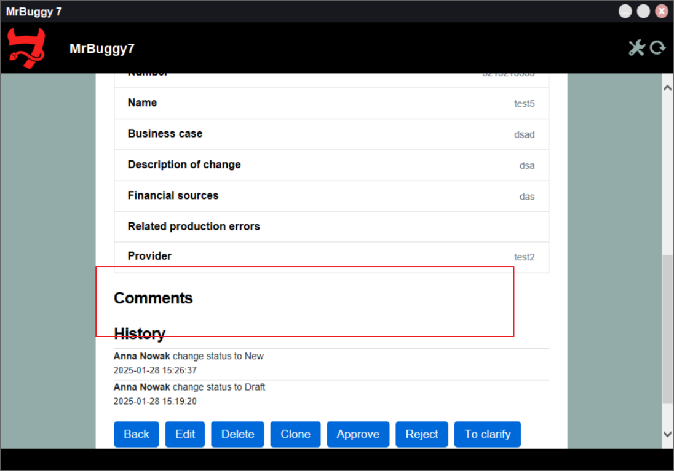

**#8**

**Title:**

After completing the edit, the CR does not switch to "read-only" mode.

**Description:**

When an administrator edits a CR, after selecting the "End" checkbox and saving the changes, the CR should switch to "read-only" mode. However, this does not happen – the edit button remains available.

**Steps to reproduce:**

1. Open the application.
2. Log in as an employee.
3. Click on the "CRs" tab.
4. Click the "New CR" button.
5. Fill in the required data.
6. Select the "End" checkbox.
7. Click the "Save" button.
8. Log out.
9. Log in as an administrator.
10. Click on the "CRs" tab.

**Expected Result:**

The CR should switch to the "New" state and enter "read-only" mode.

**Actual result:**

The CR switches to the "New" state, but both the administrator and the user can still edit it.

**Environment:**

* Application version: MrBuggy7 1.0.0.1
* OS: Windows 10

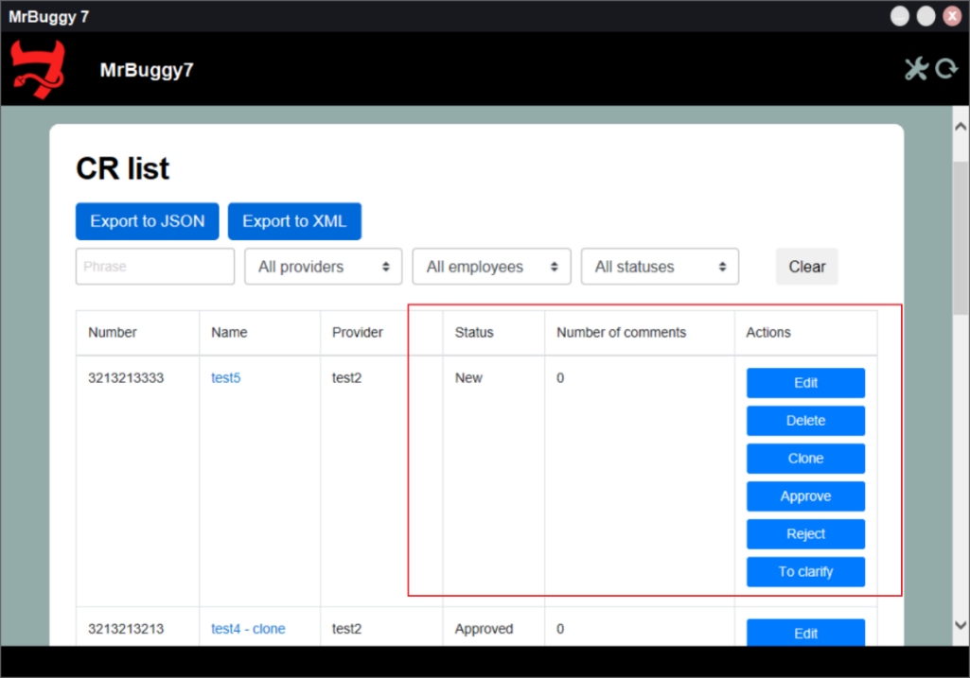**Attachment:**

**#9**

**Title:**

Unable to assign a user to a provider.

**Description:**

According to the specification, the administrator should be able to assign a user to a provider. However, this option is not available in the user management panel.

**Preconditions:**

* At least one user exists in the system.

**Steps to reproduce:**

1. Open the application.
2. Log in as an administrator.
3. Click on the "Users" tab.
4. Click on an employee.

**Expected Result:**

The administrator should be able to assign the employee to a provider.

**Actual result:**

The administrator cannot assign the employee to a provider.

**Environment:**

* Application version: MrBuggy7 1.0.0.1
* OS: Windows 10

**Attachment:**

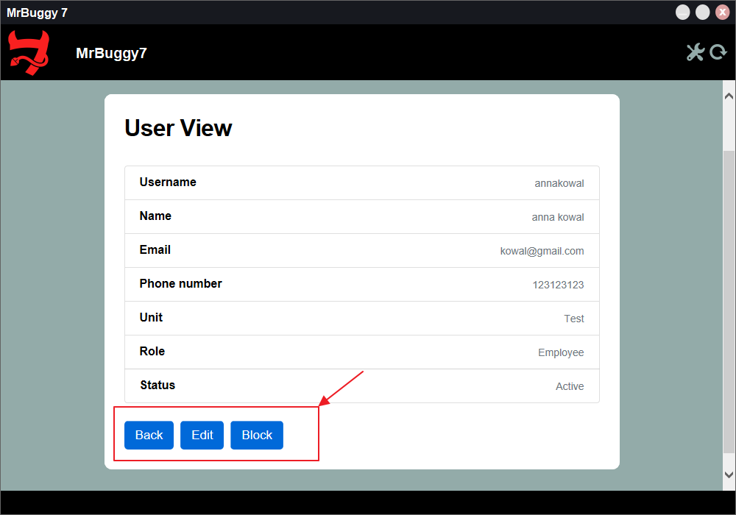

**#10**

**Title:**

Incorrect provider account creation form.

**Description:**

When creating a provider account, the form incorrectly requires assigning the provider to another provider, which should not be the case.

**Steps to reproduce:**

1. Open the application.
2. Log in as an administrator.
3. Click on the "Users" tab.
4. Click the "New provider" button.

**Expected Result:**

The form should allow creating a provider account without requiring an assignment to another provider.

**Actual result:**

The form requires assigning the provider to another provider.

**Environment:**

* Application version: MrBuggy7 1.0.0.1
* OS: Windows 10

**Attachment:**

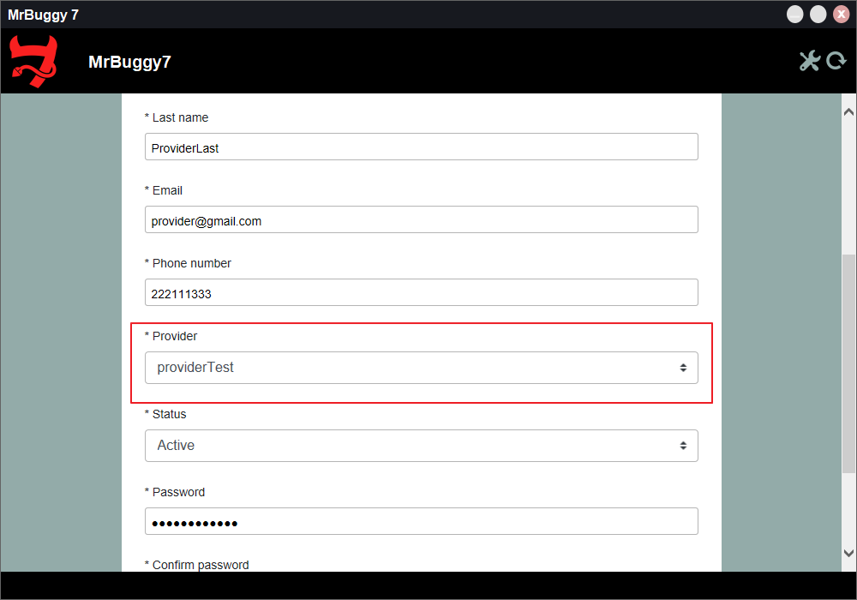

**#11**

**Title:**

Inactive tabs have an incorrect color.

**Description:**

When the user is not on a specific subpage, the tab associated with that page should be gray (#FFFFFF, opacity: 0.70).

**Steps to reproduce:**

1. Open the "aboutus.html" page.
2. Navigate to the tab section in the header.

**Expected Result:**

Inactive tabs should have a color consistent with the design template (#FFFFFF, opacity: 0.70).

**Actual result:**

Inactive tabs have an incorrect color.

**Environment:**

* Browser: Google Chrome 133.0.6943.127
* OS: Windows 10

**Attachments:**

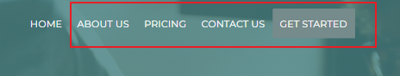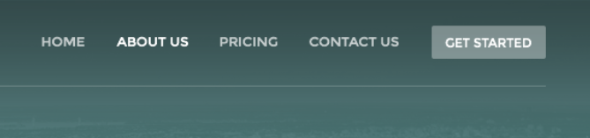

**#12**

**Title:**

The "GET STARTED" button has incorrect font size and background.

**Description:**

In the header of the page, the "GET STARTED" button should have a font size of 12px (currently it is 13px), the background should be "#FFFFFF", and the opacity should be set to 0.35 (currently it has a background of "#768b8b" and opacity of 1).

**Steps to reproduce:**

1. Open the "aboutus.html" page.
2. Navigate to the tab section in the header.

**Expected Result:**

The "GET STARTED" button should have a font-size of 12px, background of "#FFFFFF", and opacity of 0.35.

**Actual result:**

The "GET STARTED" button has a font-size of 13px, background of "#768b8b", and opacity of 1.

**Environment:**

* Browser: Google Chrome 133.0.6943.127
* OS: Windows 10

**Attachments:**

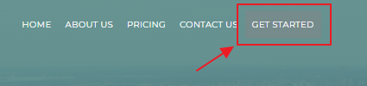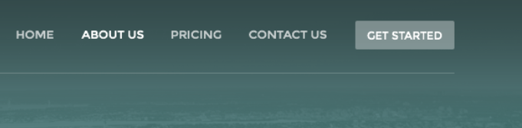

**#13**

**Title:**

Incorrect icon size and missing symbol in header.

**Description:**

According to the design, the phone icon should have a size of width: 14px and height: 14px, but it currently has width: 10.22px and height: 13px. Additionally, the icon should have an opacity of 0.70. The phone number should be displayed as "+62 202 555 0117" (the "+" is missing). The separator between the logo and the phone number ("|") should have a width of 4px, height of 23px, and opacity of 0.2, but it currently has width: 3.83px, height: 16px, and opacity of 1.

**Steps to reproduce:**

1. Open the "aboutus.html" page.
2. Navigate to the tab section in the header.

**Expected Result:**

The phone icon should have a width of 14px, height of 14px, and opacity of 0.70. The phone number should be displayed as "+62 202 555 0117". The separator "|" should have a width of 4px, height of 23px, and opacity of 0.2.

**Actual result:**

The phone icon has a width of 10.22px, height of 13px, and opacity of 1. The phone number is displayed as "62 202 555 0117". The separator "|" has a width of 3.83px, height of 16px, and opacity of 1.

**Environment:**

* Browser: Google Chrome 133.0.6943.127
* OS: Windows 10

**Attachments:**

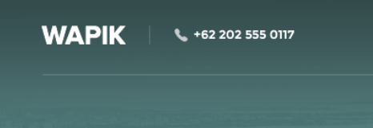

**#14**

**Title:**

Incorrect sizes for the h1:after line and the text below in section id="about-us".

**Description:**

In the section with id="about-us", the h1:after line has a width of 70px and height of 2px. It should be 69px in width and 4px in height. The text below has a width of 768px and height of 66px. It should be 702px in width and 82px in height.

**Steps to reproduce:**

1. Open the "aboutus.html" page.
2. Navigate to the section with id="about-us".

**Expected Result:**

The h1:after line should have a width of 69px and height of 4px. The text below should have a width of 702px and height of 82px.

**Actual result:**

The h1:after line has a width of 70px and height of 2px. The text below has a width of 768px and height of 66px.

**Environment:**

* Browser: Google Chrome 133.0.6943.127
* OS: Windows 10

**Attachments:** 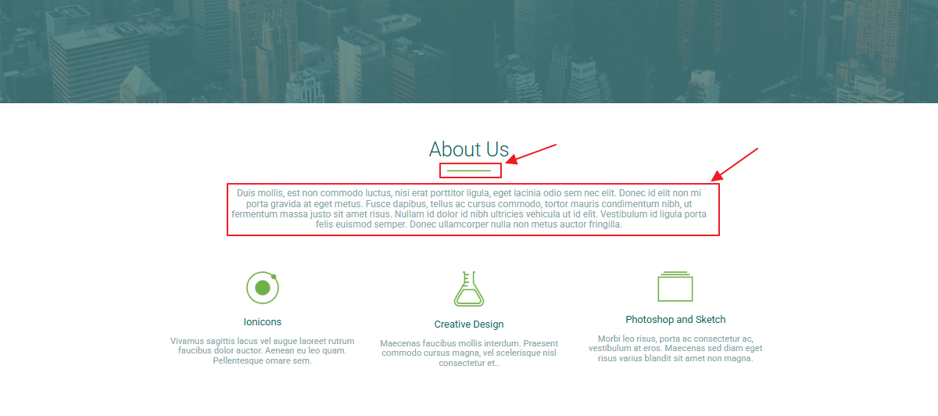

**#15**

**Title:**

Incorrect sizes for h6 headers with descriptions in section id="about-us".

**Description:**

In the section with id="about-us", the h6 headers have a size of width: 300px and height: 46px. They should have the following sizes:

1. width: 299px, height: 59px
2. width: 288px, height: 57px
3. width: 332px, height: 59px

**Steps to reproduce:**

1. Open the "aboutus.html" page.
2. Navigate to the section with id="about-us".

**Expected Result:**

The h6 headers should have the following sizes:

1. width: 299px, height: 59px
2. width: 288px, height: 57px
3. width: 332px, height: 59px.

**Actual result:**

The h6 headers have a size of width: 300px and height: 46px.

**Environment:**

* Browser: Google Chrome 133.0.6943.127
* OS: Windows 10

**Attachments:** 